

ECA 1402 – EMBEDDED SYSTEMS
EXPERIMENT 4 - 7 SEGMENT DISPLAY USING AT89C51 USING PROTEUS
Name: Danish Balaji B
Reg No: 192512122

Program:
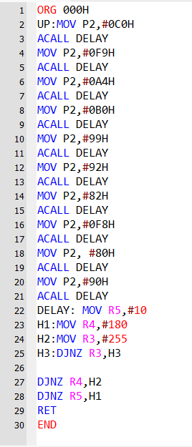

Output:
